How to set JAVA_HOME and HADOOP_HOME ?

Answer:

1. Search for jdk folder as follows

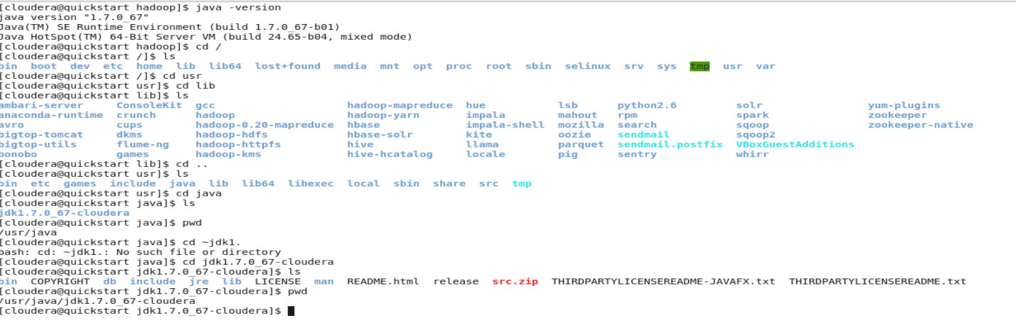

1. Create a shell script as follows

